Analysis of Heart Disease

Elias Fedai

8/5/2019

Initial Summary of Data

|  |  |  |  |  |  |  |  |  |  |
| --- | --- | --- | --- | --- | --- | --- | --- | --- | --- |
| name | type | na | mean | disp | median | mad | min | max | nlevs |
| Age | numeric | 0 | 56.1805112 | 8.9253439 | 57.0 | 8.89560 | 29.0 | 77.0 | 0 |
| Gender | numeric | 0 | 0.8194888 | 0.3849202 | 1.0 | 0.00000 | 0.0 | 1.0 | 0 |
| CP | numeric | 0 | 3.3753994 | 0.8879470 | 4.0 | 0.00000 | 1.0 | 4.0 | 0 |
| Trestbps | numeric | 58 | 131.8996479 | 19.7787266 | 130.0 | 14.82600 | 0.0 | 200.0 | 0 |
| Chol | numeric | 7 | 176.4878837 | 118.1847099 | 216.0 | 80.06040 | 0.0 | 564.0 | 0 |
| FBS | numeric | 82 | 0.2169118 | 0.4125214 | 0.0 | 0.00000 | 0.0 | 1.0 | 0 |
| RestECG | numeric | 1 | 0.7856000 | 0.8672000 | 0.0 | 0.00000 | 0.0 | 2.0 | 0 |
| Thalach | numeric | 54 | 136.7342657 | 27.0289981 | 140.0 | 29.65200 | 60.0 | 202.0 | 0 |
| Exang | numeric | 54 | 0.4335664 | 0.4960007 | 0.0 | 0.00000 | 0.0 | 1.0 | 0 |
| Oldpeak | numeric | 62 | 1.0313830 | 1.1466644 | 0.9 | 1.33434 | -2.6 | 6.2 | 0 |
| Slope | numeric | 119 | 1.7455621 | 0.6596464 | 2.0 | 0.00000 | 1.0 | 3.0 | 0 |
| CA | numeric | 320 | 0.6830065 | 0.9378238 | 0.0 | 0.00000 | 0.0 | 3.0 | 0 |
| Thal | numeric | 220 | 5.0492611 | 1.9341089 | 6.0 | 1.48260 | 3.0 | 7.0 | 0 |
| target | integer | 0 | 1.2939297 | 1.2380093 | 1.0 | 1.48260 | 0.0 | 4.0 | 0 |

*Data needs to be cleaned.

Summary of Data (clean)

|  |  |  |  |  |  |  |  |  |  |
| --- | --- | --- | --- | --- | --- | --- | --- | --- | --- |
| name | type | na | mean | disp | median | mad | min | max | nlevs |
| Age | numeric | 0 | 54.5469799 | 9.0348823 | 56.0 | 8.89560 | 29 | 77.0 | 0 |
| Gender | numeric | 0 | 0.6778523 | 0.4680852 | 1.0 | 0.00000 | 0 | 1.0 | 0 |
| CP | numeric | 0 | 3.1610738 | 0.9644671 | 3.0 | 1.48260 | 1 | 4.0 | 0 |
| Trestbps | numeric | 0 | 131.6543624 | 17.7458108 | 130.0 | 14.82600 | 94 | 200.0 | 0 |
| Chol | numeric | 0 | 246.8557047 | 52.6070752 | 242.5 | 47.44320 | 100 | 564.0 | 0 |
| FBS | numeric | 0 | 0.1442953 | 0.3519800 | 0.0 | 0.00000 | 0 | 1.0 | 0 |
| RestECG | numeric | 0 | 0.9932886 | 0.9949140 | 1.0 | 1.48260 | 0 | 2.0 | 0 |
| Thalach | numeric | 0 | 149.5000000 | 22.9670017 | 152.5 | 22.98030 | 71 | 202.0 | 0 |
| Exang | numeric | 0 | 0.3288591 | 0.4705889 | 0.0 | 0.00000 | 0 | 1.0 | 0 |
| Oldpeak | numeric | 0 | 1.0570470 | 1.1644426 | 0.8 | 1.18608 | 0 | 6.2 | 0 |
| Slope | numeric | 0 | 1.6040268 | 0.6175742 | 2.0 | 1.48260 | 1 | 3.0 | 0 |
| CA | numeric | 0 | 0.6744966 | 0.9382019 | 0.0 | 0.00000 | 0 | 3.0 | 0 |
| Thal | numeric | 0 | 4.7382550 | 1.9398218 | 3.0 | 0.00000 | 3 | 7.0 | 0 |
| target | factor | 0 | NA | 0.4630872 | NA | NA | 138 | 160.0 | 2 |
| Disease | factor | 0 | NA | 0.4630872 | NA | NA | 138 | 160.0 | 2 |

Table of Heart Disease

|  |  |
| --- | --- |
| Var1 | Freq |
| 0 | 160 |
| 1 | 138 |

*There seems to be a lower count on heart disease cases than non heart disease cases.

### Cholesterol

## Min. 1st Qu. Median Mean 3rd Qu. Max.   
## 100.0 211.0 242.5 246.9 275.8 564.0

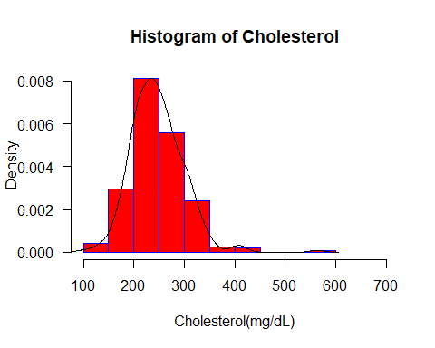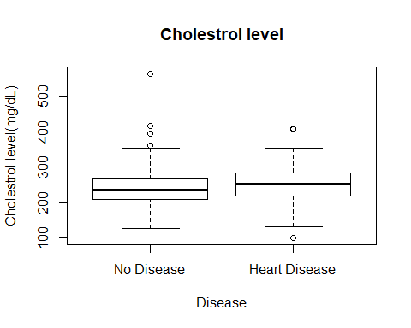

*Both heart and no disease display slightly elevated cholestrol levels.

### Gender

## Female Male   
## 96 202

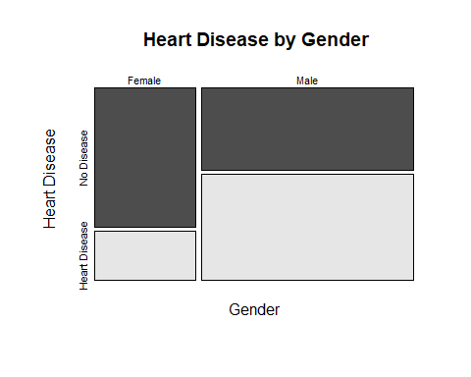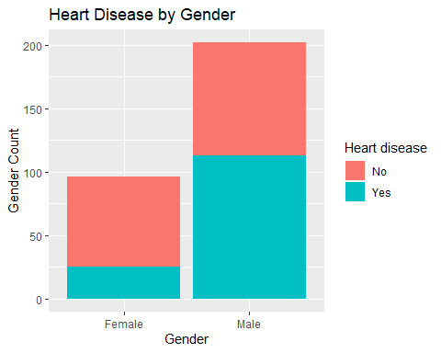 *Graphs/tables display more males where used in this study also there is a higher frequency of males with heart disease.

### Thalassemia

## fixed defect normal reversable defect   
## 18 164 116

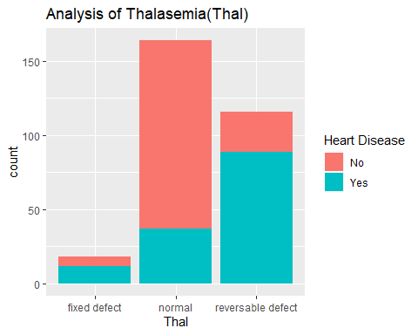 *Reversable defect displays a higher measure for heart disease.

### Oldpeak

## Min. 1st Qu. Median Mean 3rd Qu. Max.   
## 0.000 0.000 0.800 1.057 1.600 6.200

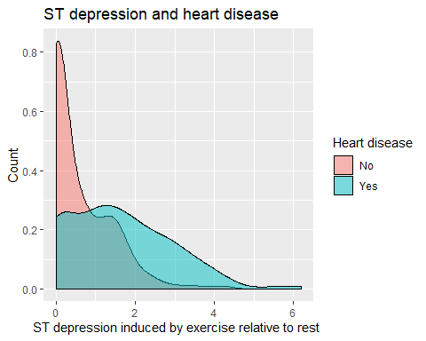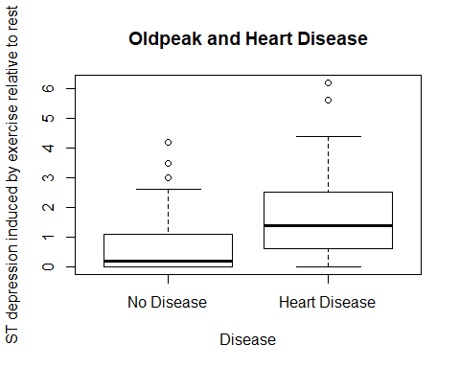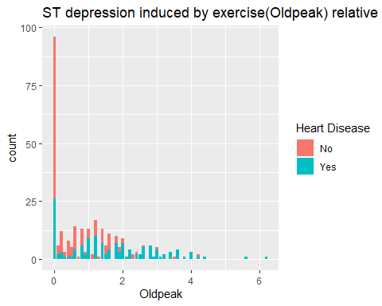 *Visuals for ST levels show a heavy right skewness. The no disease displays slightly more outliers.

### Fasting blood sugar

## false true   
## 255 43

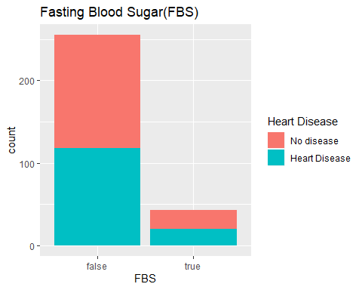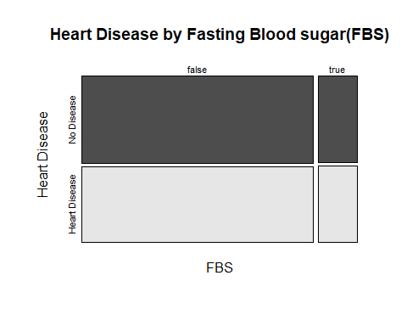 *Visuals appear to show not much possible significance for fasting blood sugar.

### Resting Electrocardiographic

## normal ST-T abnorm V.hypertrophy   
## 148 4 146

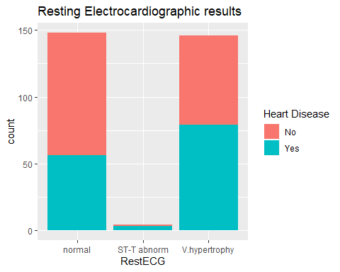 *V hypertrophy displayed a higher count for heart disease.

### Logistic regression

##   
## Call:  
## glm(formula = target ~ Gender + Age + CP + Trestbps + RestECG +   
## Thalach + Exang + Slope + CA + Thal + Oldpeak + FBS, family = binomial,   
## data = combinedclean)  
##   
## Deviance Residuals:   
## Min 1Q Median 3Q Max   
## -2.7161 -0.5050 -0.1469 0.3476 2.8296   
##   
## Coefficients:  
## Estimate Std. Error z value Pr(>|z|)   
## (Intercept) -2.81103 2.73947 -1.026 0.304835   
## GenderMale 1.39407 0.50438 2.764 0.005712 **   
## Age -0.01034 0.02440 -0.424 0.671677   
## CPatypical angina -0.82837 0.55808 -1.484 0.137722   
## CPnon-anginal pain -1.84643 0.50202 -3.678 0.000235 ***  
## CPtypical angina -2.12575 0.66391 -3.202 0.001365 **   
## Trestbps 0.02440 0.01125 2.169 0.030095 *   
## RestECGST-T abnorm 0.68976 2.25026 0.307 0.759206   
## RestECGV.hypertrophy 0.54077 0.37750 1.432 0.152004   
## Thalach -0.01632 0.01097 -1.487 0.136973   
## Exangyes 0.70812 0.43582 1.625 0.104205   
## Slopeflat 0.71177 0.84746 0.840 0.400971   
## Slopeupsloping -0.45645 0.92176 -0.495 0.620461   
## CA 1.29252 0.27743 4.659 3.18e-06 ***  
## Thalnormal 0.06636 0.78376 0.085 0.932521   
## Thalreversable defect 1.50432 0.76483 1.967 0.049198 *   
## Oldpeak 0.38048 0.22962 1.657 0.097526 .   
## FBStrue -0.56212 0.60200 -0.934 0.350429   
## ---  
## Signif. codes: 0 '***' 0.001 '**' 0.01 '*' 0.05 '.' 0.1 ' ' 1  
##   
## (Dispersion parameter for binomial family taken to be 1)  
##   
## Null deviance: 411.49 on 297 degrees of freedom  
## Residual deviance: 193.03 on 280 degrees of freedom  
## AIC: 229.03  
##   
## Number of Fisher Scoring iterations: 6

*Parameters that were seen to be insignificant will be removed.

##   
## Call:  
## glm(formula = target ~ Gender + CP + CA + Trestbps + Thal + Oldpeak,   
## family = binomial, data = training1)  
##   
## Deviance Residuals:   
## Min 1Q Median 3Q Max   
## -2.5514 -0.4789 -0.1509 0.3754 2.5420   
##   
## Coefficients:  
## Estimate Std. Error z value Pr(>|z|)   
## (Intercept) -2.188512 2.129288 -1.028 0.304037   
## GenderMale 1.323882 0.540842 2.448 0.014372 *   
## CPatypical angina -2.038021 0.694037 -2.936 0.003320 **   
## CPnon-anginal pain -2.380433 0.565135 -4.212 2.53e-05 ***  
## CPtypical angina -1.591209 0.741720 -2.145 0.031929 *   
## CA 0.716567 0.283673 2.526 0.011536 *   
## Trestbps 0.002312 0.013238 0.175 0.861361   
## Thalnormal -0.195208 1.112786 -0.175 0.860748   
## Thalreversable defect 1.581107 1.117609 1.415 0.157150   
## Oldpeak 0.996666 0.296982 3.356 0.000791 ***  
## ---  
## Signif. codes: 0 '***' 0.001 '**' 0.01 '*' 0.05 '.' 0.1 ' ' 1  
##   
## (Dispersion parameter for binomial family taken to be 1)  
##   
## Null deviance: 268.61 on 193 degrees of freedom  
## Residual deviance: 134.01 on 184 degrees of freedom  
## AIC: 154.01  
##   
## Number of Fisher Scoring iterations: 6

## Actual  
## Predicted 0 1  
## 0 89 23  
## 1 12 70

## [1] 0.1804124

*Training model displayed 18% misclassification error. Which will give an Accuracy of 82%

## [1] 1.339913e-24

*fit test p value indicates this model is significant.

##   
## Call:  
## glm(formula = target ~ Gender + CP + CA + Trestbps + Thal + Oldpeak,   
## family = binomial, data = test1)  
##   
## Deviance Residuals:   
## Min 1Q Median 3Q Max   
## -2.1894 -0.4441 -0.1346 0.2815 2.6023   
##   
## Coefficients:  
## Estimate Std. Error z value Pr(>|z|)   
## (Intercept) -6.72817 2.91477 -2.308 0.020982 *   
## GenderMale 0.86534 0.91177 0.949 0.342580   
## CPatypical angina -0.62171 0.92270 -0.674 0.500439   
## CPnon-anginal pain -2.00075 0.82290 -2.431 0.015042 *   
## CPtypical angina -4.58981 1.68282 -2.727 0.006383 **   
## CA 1.76310 0.48720 3.619 0.000296 ***  
## Trestbps 0.03886 0.01725 2.253 0.024255 *   
## Thalnormal -0.92804 1.23453 -0.752 0.452209   
## Thalreversable defect 0.90323 1.16946 0.772 0.439908   
## Oldpeak 0.69001 0.31949 2.160 0.030791 *   
## ---  
## Signif. codes: 0 '***' 0.001 '**' 0.01 '*' 0.05 '.' 0.1 ' ' 1  
##   
## (Dispersion parameter for binomial family taken to be 1)  
##   
## Null deviance: 142.284 on 103 degrees of freedom  
## Residual deviance: 64.742 on 94 degrees of freedom  
## AIC: 84.742  
##   
## Number of Fisher Scoring iterations: 6

## Actual  
## Predicted 0 1  
## 0 54 9  
## 1 5 36

## [1] 0.1346154

*Test model displayed a 13.5% misclassification error. Which will give an Accuracy of 86.5%

## [1] 4.966e-13

*Fit test p value indicates this model is signicant.

##   
## Call:  
## glm(formula = target ~ RestECG + Age, family = binomial, data = training2)  
##   
## Deviance Residuals:   
## Min 1Q Median 3Q Max   
## -2.245 -1.034 -0.596 1.021 1.906   
##   
## Coefficients:  
## Estimate Std. Error z value Pr(>|z|)   
## (Intercept) -4.71102 1.02778 -4.584 4.57e-06 ***  
## RestECGST-T abnorm 1.00318 1.20653 0.831 0.4057   
## RestECGV.hypertrophy 0.56444 0.30067 1.877 0.0605 .   
## Age 0.08084 0.01869 4.325 1.52e-05 ***  
## ---  
## Signif. codes: 0 '***' 0.001 '**' 0.01 '*' 0.05 '.' 0.1 ' ' 1  
##   
## (Dispersion parameter for binomial family taken to be 1)  
##   
## Null deviance: 288.04 on 207 degrees of freedom  
## Residual deviance: 260.11 on 204 degrees of freedom  
## AIC: 268.11  
##   
## Number of Fisher Scoring iterations: 4

## Actual  
## Predicted 0 1  
## 0 76 35  
## 1 32 65

## [1] 0.3221154

*training model displayed 32.2% misclassifcation error. which will give an Accuracy of 67.8%

## [1] 3.748741e-06

*Fit test p value indicates this model is signifcant.

##   
## Call:  
## glm(formula = target ~ RestECG + Age, family = binomial, data = test2)  
##   
## Deviance Residuals:   
## Min 1Q Median 3Q Max   
## -1.1837 -1.1750 -0.8519 1.1780 1.5444   
##   
## Coefficients:  
## Estimate Std. Error z value Pr(>|z|)   
## (Intercept) -0.7868688 1.3239068 -0.594 0.5523   
## RestECGV.hypertrophy 0.8230585 0.4594067 1.792 0.0732 .  
## Age -0.0006296 0.0235104 -0.027 0.9786   
## ---  
## Signif. codes: 0 '***' 0.001 '**' 0.01 '*' 0.05 '.' 0.1 ' ' 1  
##   
## (Dispersion parameter for binomial family taken to be 1)  
##   
## Null deviance: 122.58 on 89 degrees of freedom  
## Residual deviance: 119.18 on 87 degrees of freedom  
## AIC: 125.18  
##   
## Number of Fisher Scoring iterations: 4

## Actual  
## Predicted 0 1  
## 0 39 28  
## 1 13 10

## [1] 0.4555556

*Test model displayed 45.6% misclassification error. Which will give an Accuracy of 54.4%

## [1] 0.1822464

*Fit test p value indicates this model is not significant.